Consider CPT 2007

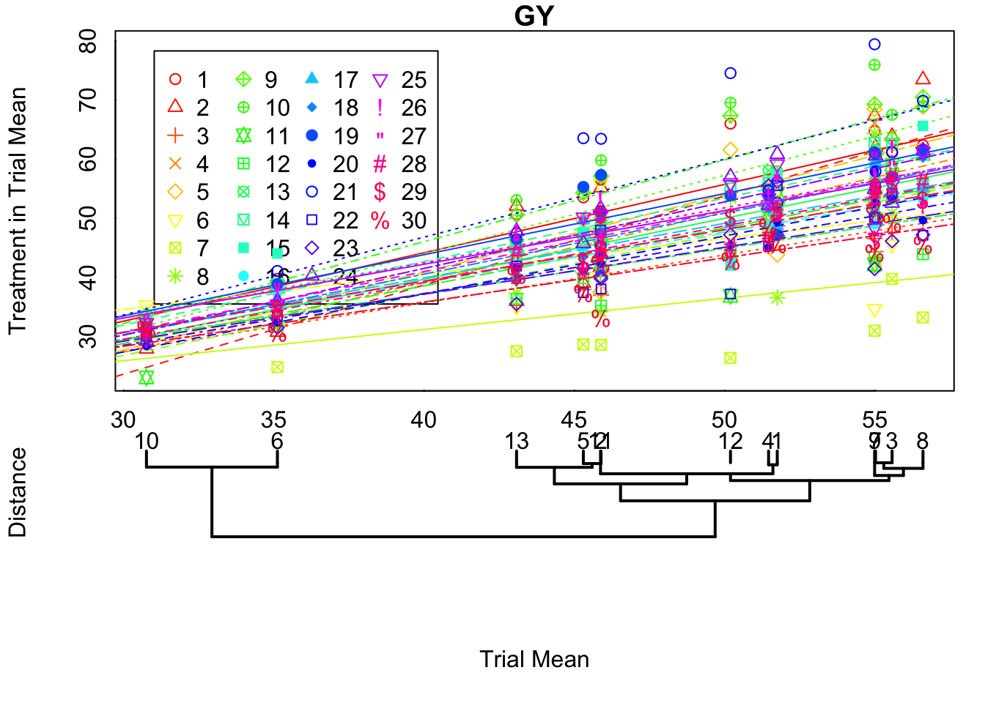
Treatment 21 seems to have performed exceptionally well in four of these thirteen trials. How can we decide if these specific interactions are meaningful?

We first consider the treatment-trial effects as a random variable. Is it distributed as a univariate normal?
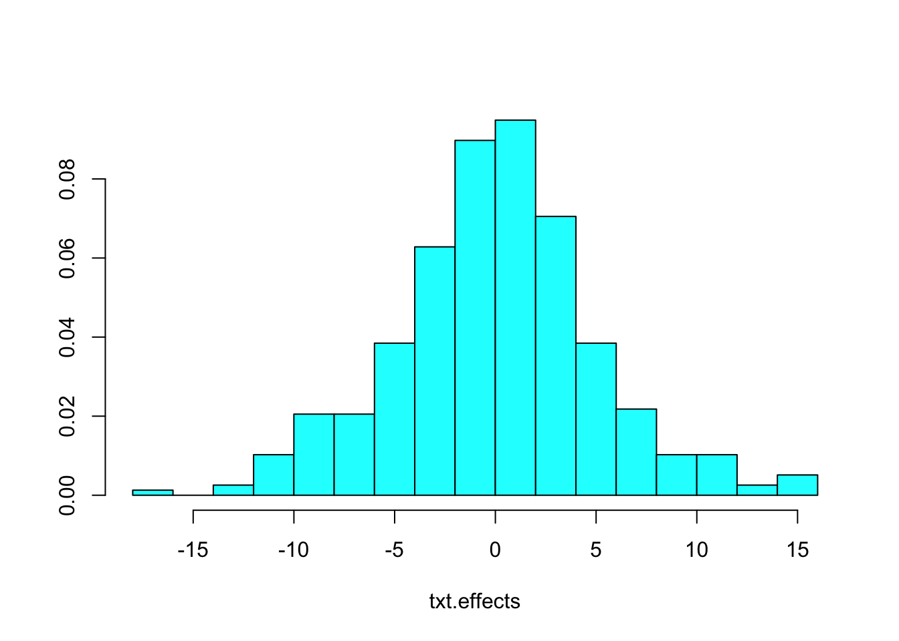
Since this appears to be a single random effect, we find the standard deviation and plot the treatment trial pairs that are greater than 3sigma

